**Plugin Use Case Document**

**AI Powered Project Evaluator**

**Overview**

AI-Powered Project Evaluator Tool automates the process of end-to-end project assignment and assessment. By integrating into the Learning Management System (LMS), this tool aims to make project evaluation more efficient, objective, and scalable. It provides a comprehensive solution for both educators and learners by dynamically generating project assignments and providing detailed, actionable feedback.

**Problem Statement**

Traditional methods of evaluating hands-on projects are often subjective, inconsistent, and require significant manual effort from instructors. This manual process makes it difficult to assess projects at scale and can lead to evaluations that fail to accurately measure a student's practical skills and real-world problem-solving abilities. There is a clear need for a tool that can objectively and efficiently evaluate projects based on multiple parameters, such as code quality, functionality, and documentation.

**Proposed Solution**

The AI-Powered Project Evaluator Tool addresses these challenges by automating the entire project assessment lifecycle. The tool has two main functions:

**• Project Generation:** It analyzes course content to dynamically create relevant project problem statements. The academy team can review, edit, and approve these AI-generated assignments, which include objectives, expected features, constraints, and success criteria.

**• Project Evaluation:** Learners can submit their work as code files, ZIP archives, or Git repository links. The tool then uses AI models to assess the project based on defined criteria, providing a score and detailed feedback through comprehensive analysis of code quality, functionality, and documentation.

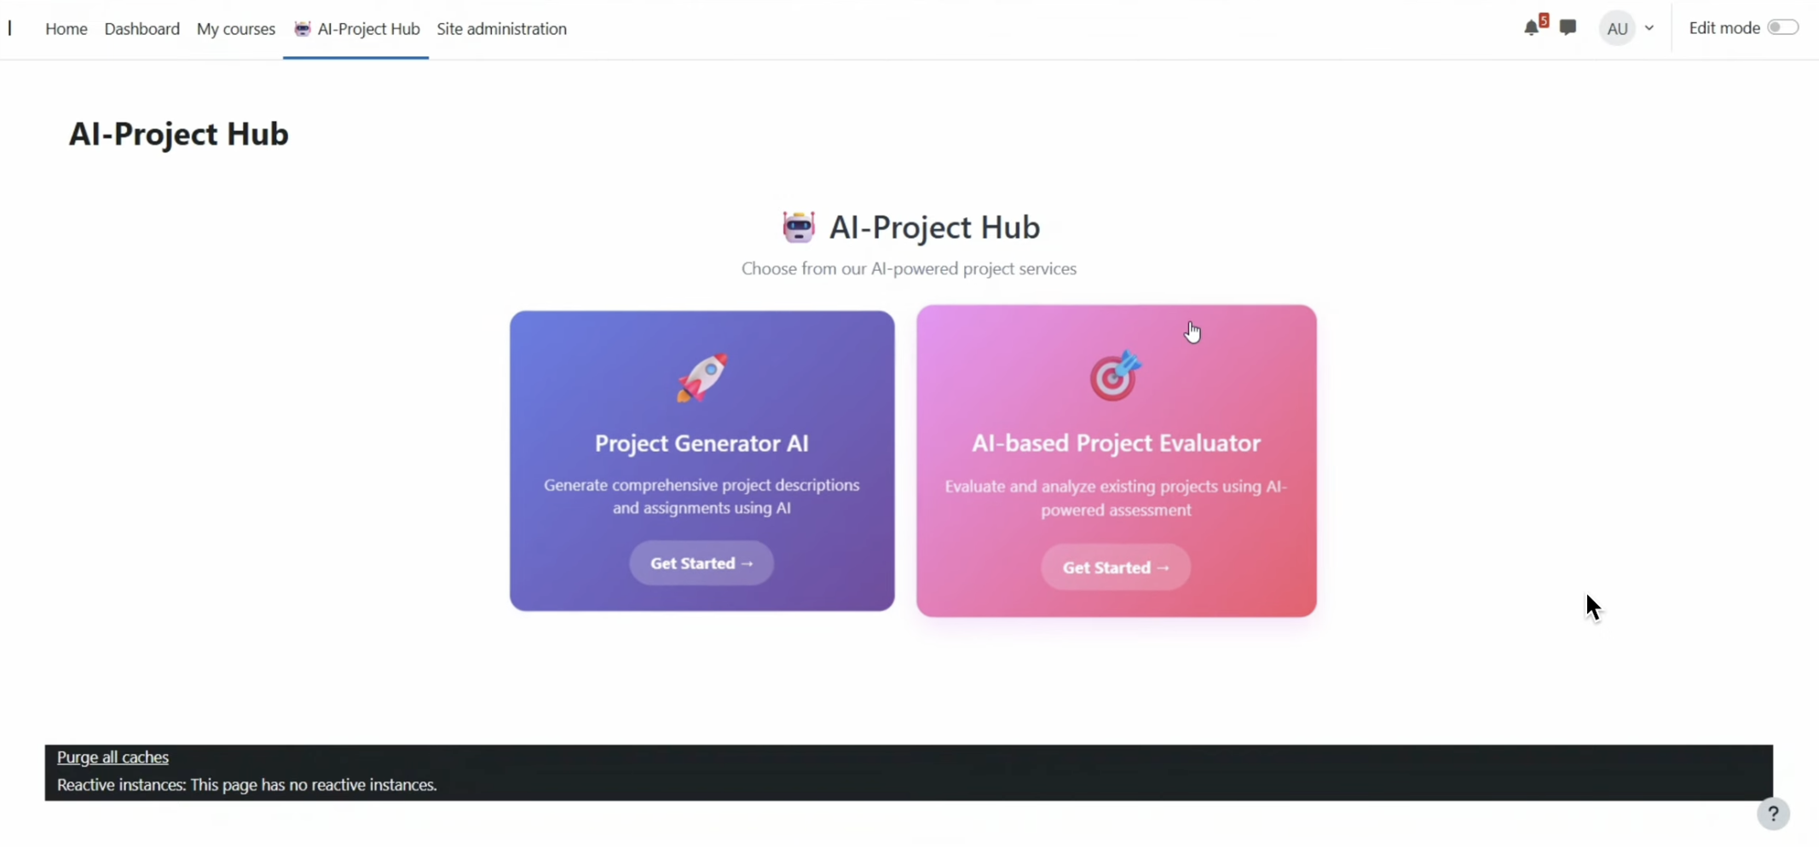

**Key Features:**

**• AI-Generated Project Problem Statements:** Creates customized project prompts aligned with course content using Snowflake Cortex with Claude-3.5-Sonnet integration.

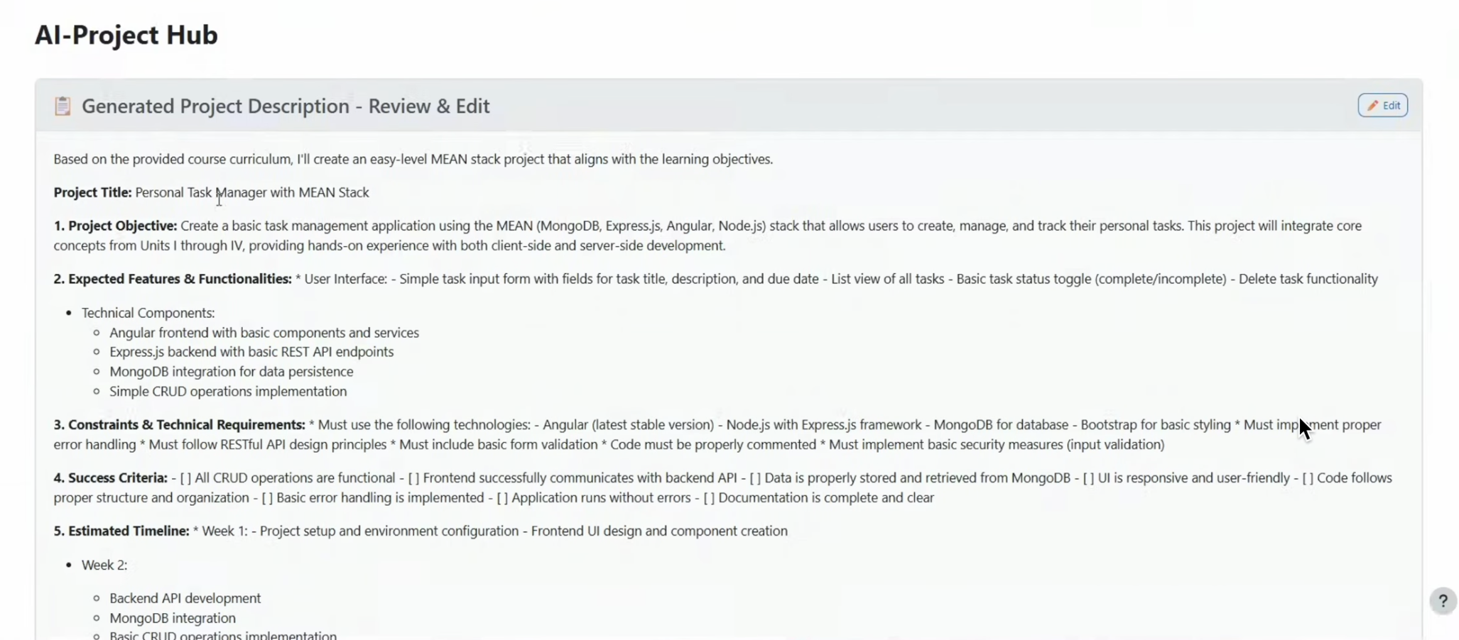

**• Automated Scoring:** Assigns scores for Code Quality (out of 35), Functionality & Correctness (out of 45), and Documentation (out of 20) using standardized evaluation criteria.

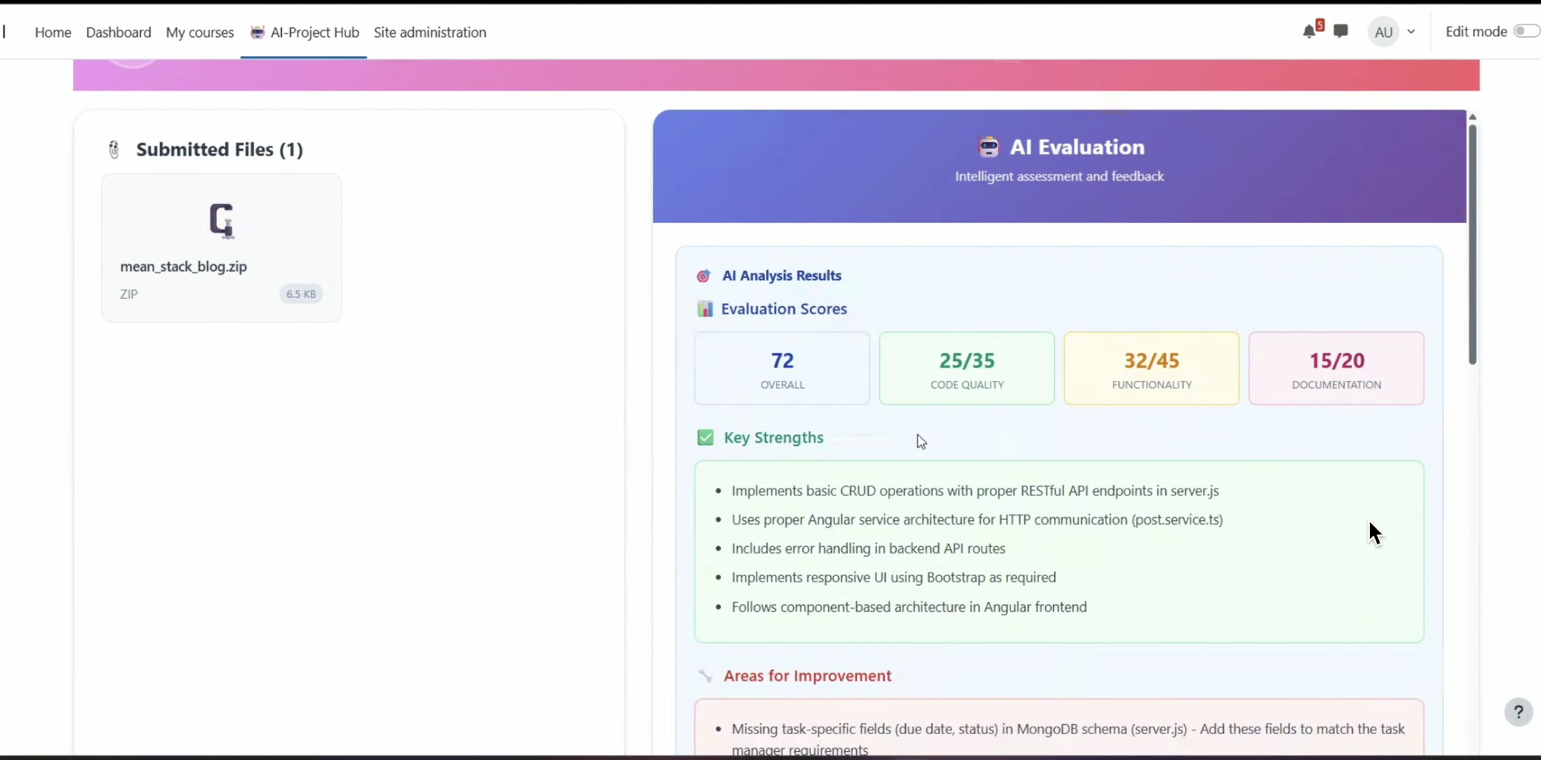

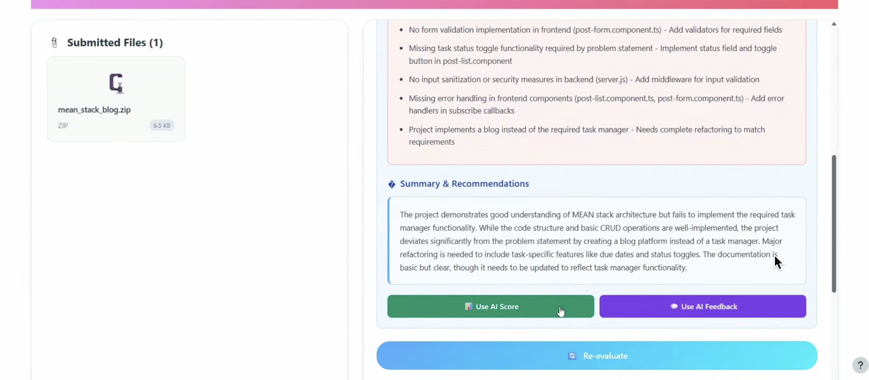

**• Detailed Feedback Reports:** Generates comprehensive reports outlining project strengths, areas for improvement, and provides code snippets to illustrate issues with actionable recommendations.

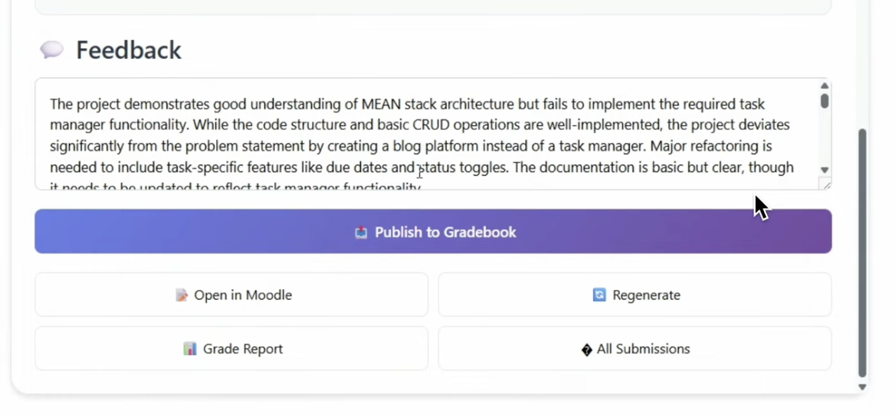

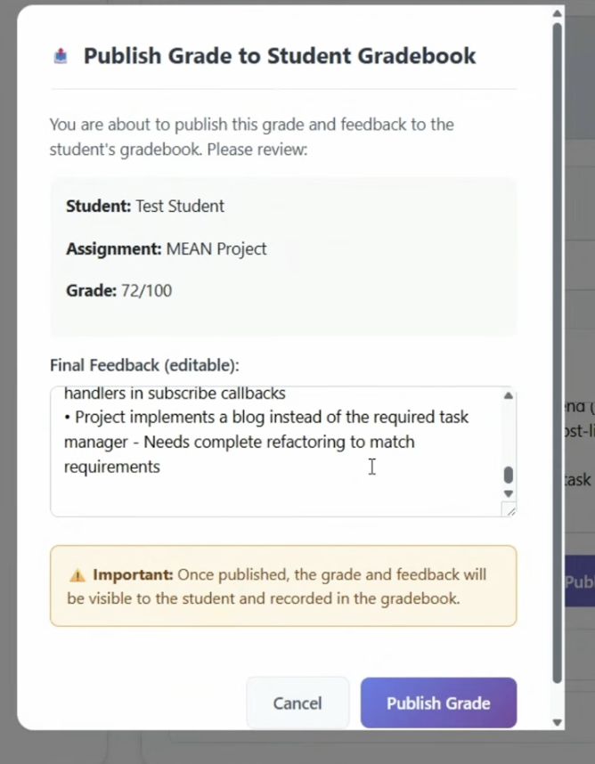

**• Support for Multiple Submission Formats:** Accepts code file uploads, ZIP archives, and Git repository links with intelligent content detection and GitHub repository scraping capabilities.



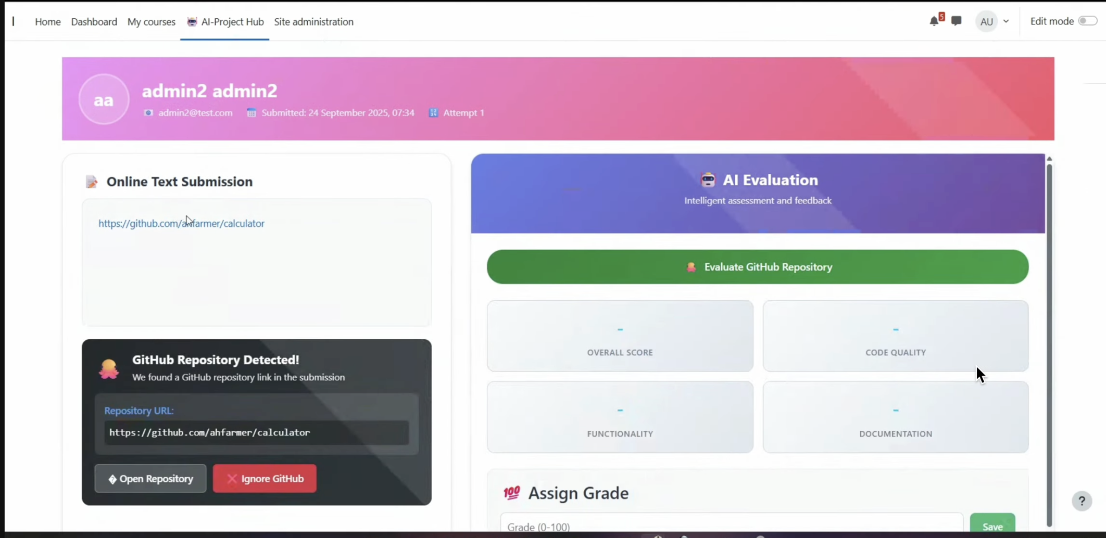

**• Seamless Moodle Integration:** Native LMS integration with gradebook publishing, user management, and institutional workflow compliance.

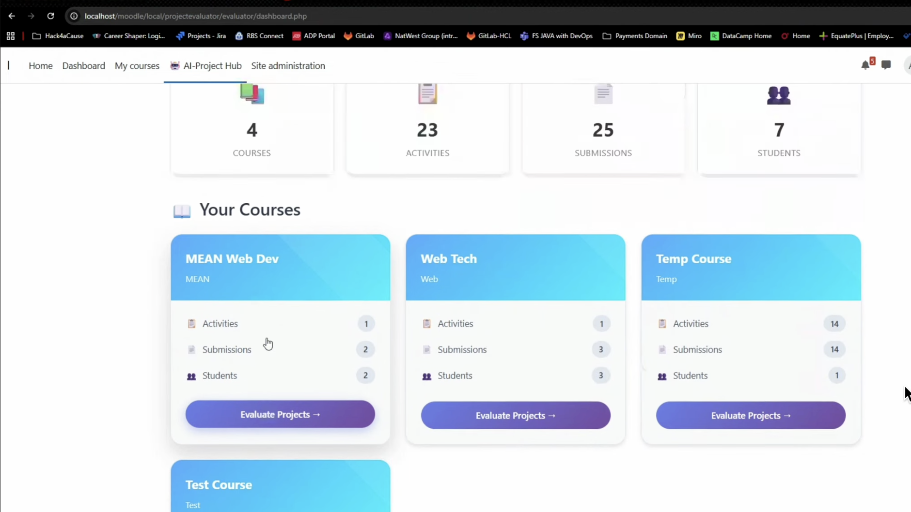

**• Advanced GitHub Analysis:** Comprehensive repository evaluation including commit history analysis, version control patterns, and collaborative development insights.



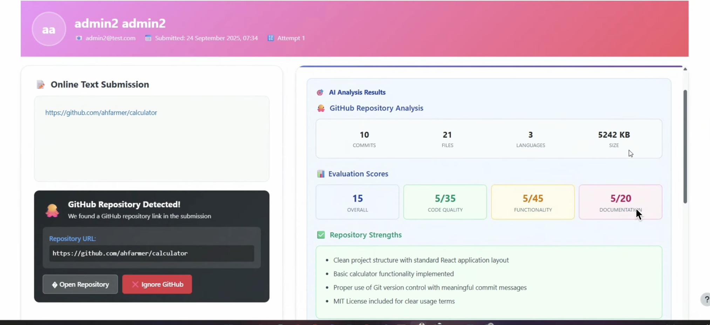

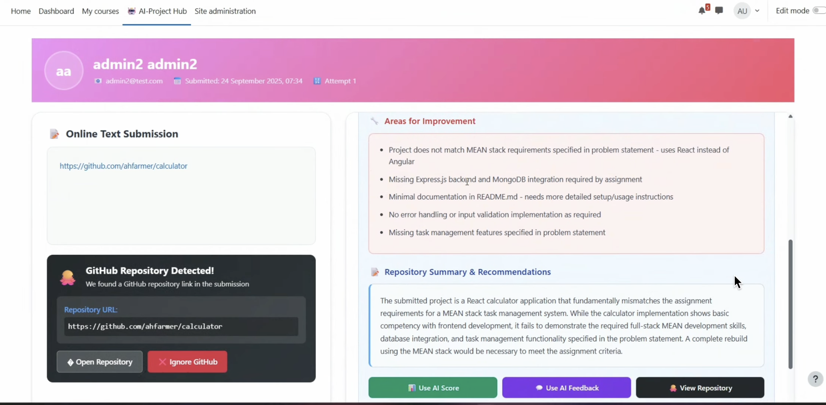

**Benefits**

**• Efficiency:** Rapid, automated generation of projects and evaluations with 60-80% reduction in grading time through streamlined assessment workflows.

**• Fairness:** Consistent scoring using standardized AI prompts eliminating human bias and ensuring objective evaluation across all submissions.

**• Actionable Feedback:** Clear strengths, weaknesses, and improvement tips for learners with detailed analysis and code-specific recommendations for skill development.

**• Encourages Real-World Problem Solving:** The AI-generated projects are aligned with industry use cases, which helps enhance job readiness and practical application of learned concepts**.**

**• Scalability:** Supports thousands of concurrent evaluations enabling institutions to handle large student populations without proportional increases in evaluation resources.

**Impact on Non-Profits**

This tool can have a significant impact on non-profits that focus on education and professional development. Training programs can scale technical education without hiring large review teams, providing learners with immediate, unbiased feedback and improving job readiness at minimal cost. The consistent and objective grading frees up instructor time, allowing them to focus on mentoring and personalized support rather than manual evaluation. Educational organizations gain access to professional-grade assessment tools, democratizing high-quality technical education delivery.

**Competitive Advantage**

Combines dynamic project creation with automated evaluation in a single comprehensive platform. Features advanced GitHub integration with commit history analysis, native Moodle LMS compatibility, and multi-format submission processing.Can be easily integrated with existing learning platforms and supports multiple file types and programming languages—features rarely offered together in competing solutions. The modular microservices architecture enables easy customization and extension for institutional requirements.

**Conclusion**

This AI-Powered Project Evaluator Tool provides a robust solution for modernizing project-based learning. By leveraging AI, it not only generates the problem statements but also streamlines the assessment process, provides consistent feedback, and helps learners develop their practical skills. This makes it an invaluable tool for any educational institution or non-profit organization looking to enhance the quality and scalability of their curriculum while maintaining rigorous evaluation standards and accelerating student success in practical skill development.